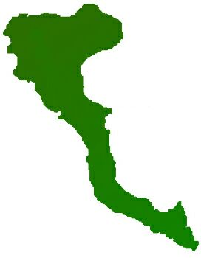

|  |  |
| --- | --- |
| **Team: 3-D Protocol number: 4** | |
|  | |
| **Author:** Arenas Pérez, Pedro José | **Date**: 7.12.2020 |
| **Place:** MS Teams at 13.30 hrs. |
| **Participants:**  - Adnan, Muhammad  - Arenas, Pedro  - Shahid, Arsalan  - Ur Rehman, Mutee | |

| **Protocol of the meeting of 7 December 2020** | | |
| --- | --- | --- |
| **Topic** | **Results** | **Time** |
| Tasks | Mr. Arenas will work on content fetching via Spring Scheduled Task | 10 min |
|  | Mr. Shahid will work on content filtering via title, genre and other parameters | 10 min |
|  | Mr. Adnan is still working on front-end tasks, current state:   * Create Angular Project, * Integrate the HTML Template into Angular application. * Adding required libraries. * Creating the application structure. * Integrate the template, create components, * Create the logo. | 10 min |
| Project decisions | New team leader until 14.12 will be Mr. Ashar | 1 min |
| Other Topics | Recap about already done tasks:   * As agreed, Mr. Arenas designed Database model and prepared a docker container with the server, together with a detail documentation on how to launch it. * Mr. Arenas also completed ORM through Entity and Repository layer. * Some CRUD operations on Service layer are already done too. | 10 min |